Name: ______________________________________ Date: ________________________

Student Exploration: Triple Beam Balance
To submit an assignment: Open the word document and save it using your last name first initial followed by lesson name. Use the lesson name given in the assignment. For example “Week1WritingAssignment” for John Smith should be: “SmithJWeek1WritingAssignment”.
Vocabulary: fulcrum, lever, mass, rider, triple beam balance

Fulcrum - The point on which a lever rests or is supported.

Lever – A rigid bar resting on a pivot, used to help move a heavy or firmly fixed load with one end when pressure is applied to the other.

Mass - A coherent, typically large body of matter with no definite shape.

Rider - A person who is riding or who can ride something, esp. a horse or bicycle.

Triple Beam Balance - A triple beam balance is a type of scale commonly used in a laboratory to determine the mass of sample.

Prior Knowledge Questions (Do these BEFORE using the Gizmo.)

- A lever is a long beam that is set on a pointed fulcrum. A heavy rock is placed on a lever, as shown. Where would you push down on the lever to lift the rock MOST EASILY?

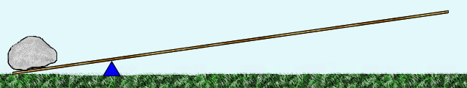
1. Here

- Suppose you wanted to balance the rock with a smaller rock. Where would you put the smaller rock to balance the beam with the larger rock?

On the right side of the fulcrum.

Gizmo Warm-up
A triple beam balance is a type of lever that is used to measure mass, or the amount of matter in an object. An object with an unknown mass is placed on the measurement tray. On the other side of a fulcrum, a set of sliding weights, called riders, slide on beams to balance the object.

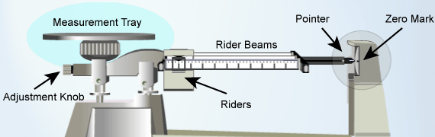

Practice using the balance in the Triple Beam Balance Gizmo™. (Continued on next page)

Activity:  Measuring mass | Get the Gizmo ready:  - Set all the Riders to 0. | 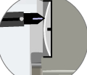

Question: How is a triple beam balance used to find mass?

- Observe: The riders have masses of 10 grams (top), 100 grams (middle), and 1 gram (bottom). Drag the 10-gram rider to 100. At this position it balances a 100 gram mass.

What happens to the pointer? It leans all the way to the right.

- Compare: Place each object on the measurement tray, one at a time. Which objects have a mass greater than 100 grams? How do you know?

The Cone, Cube, and Light Bulb all have a mass greater than 100 grams. I found this out using the Triple Beam Balance Gizmo with the 10-gram rider set to 100.

- Compare: Move the 10-gram rider back to 0, and move the 100-gram rider to 200.

    - Which objects have a mass greater than 200 grams? Cone, Cube, Light Bulb.

    - Which objects have a mass greater than 300 grams? Cone, Cube.

- Measure: Move the 100-gram rider back to 0. Place the light bulb on the tray.

- Move the 100-gram rider to the right, one notch at a time, until the pointer sinks. Now move the 100 gram rider back to the left one notch. (The pointer should lift up.)
- Move the 10-gram rider to the right, one notch at a time, until the pointer sinks below the zero mark. Now move the rider back to the left one notch.
- Slowly move the 1-gram rider until the pointer lines up with the zero mark.

- Calculate: The mass of the light bulb is the sum of the values on each rider. To get a magnified view of the 1-gram rider, place the cursor over that rider. (Each tick mark represents 0.1 g.) Write your answer to the nearest 0.1 gram.

100-g rider: 200 10-g rider: 40 1-g rider: 5.6

Mass of the light bulb: 245.6 grams

- Practice: Use the Gizmo to find the mass of the other objects. Write their masses below.

Paper clips: 5.4 grams Cone: 542 grams Cube: 429.3

